**DAY-2**

**Method Referencing**

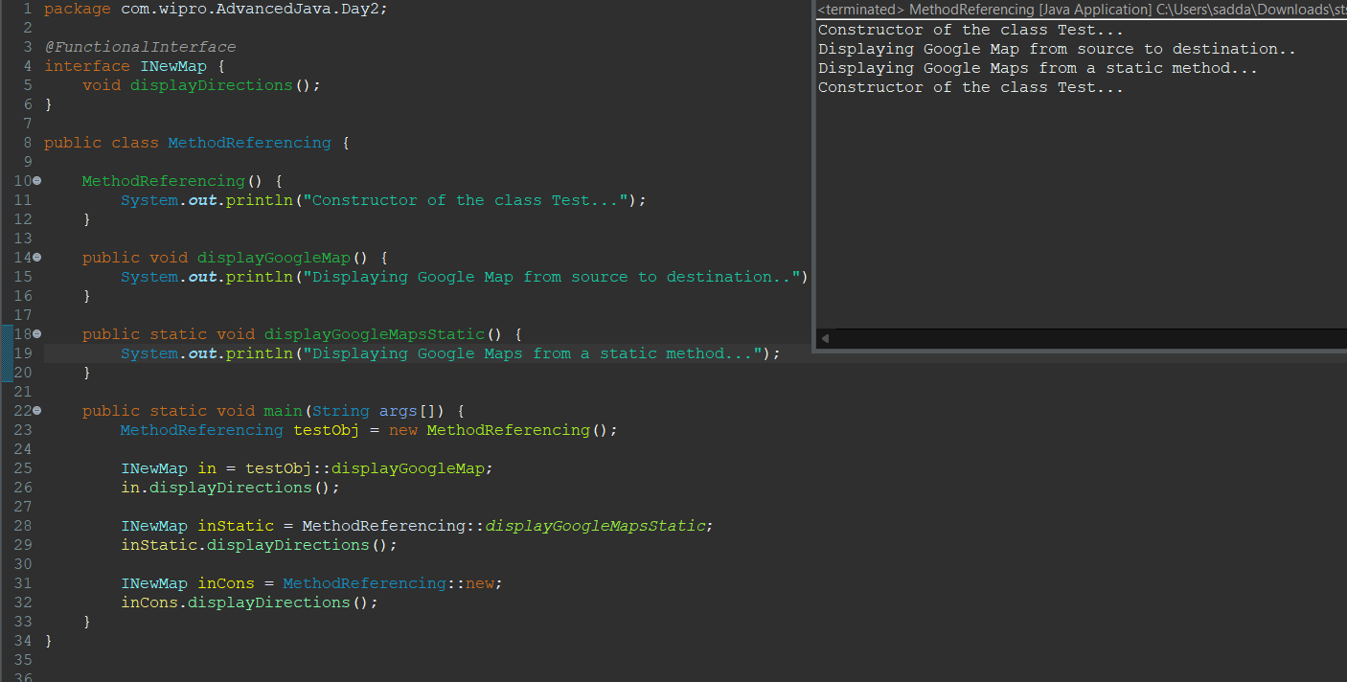

**File Writer**

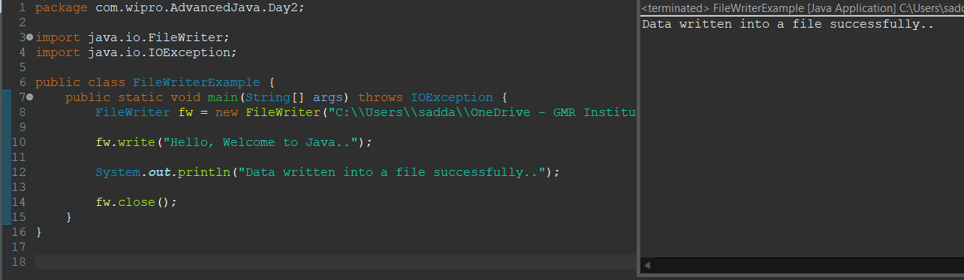

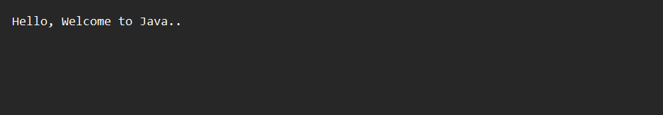

**File Reader**

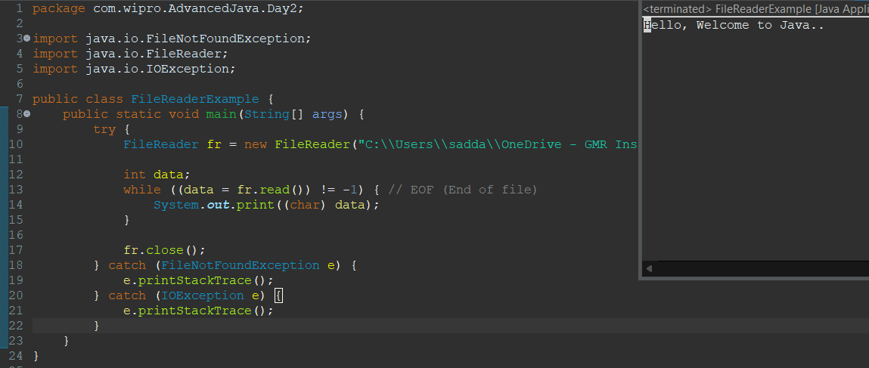



**Buffered Writer**

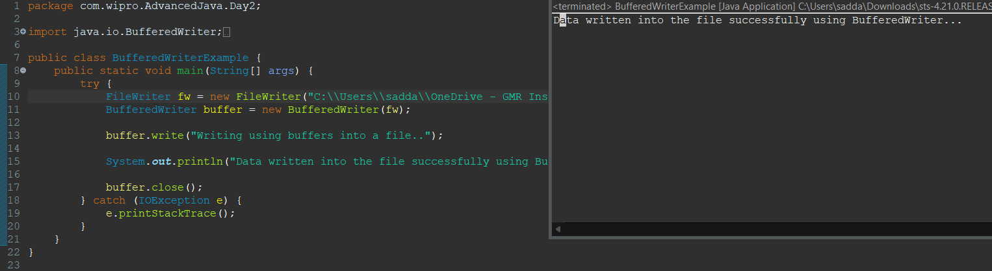

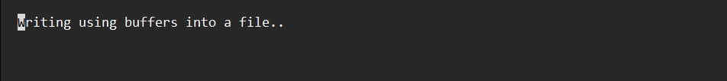

**Buffered Reader**

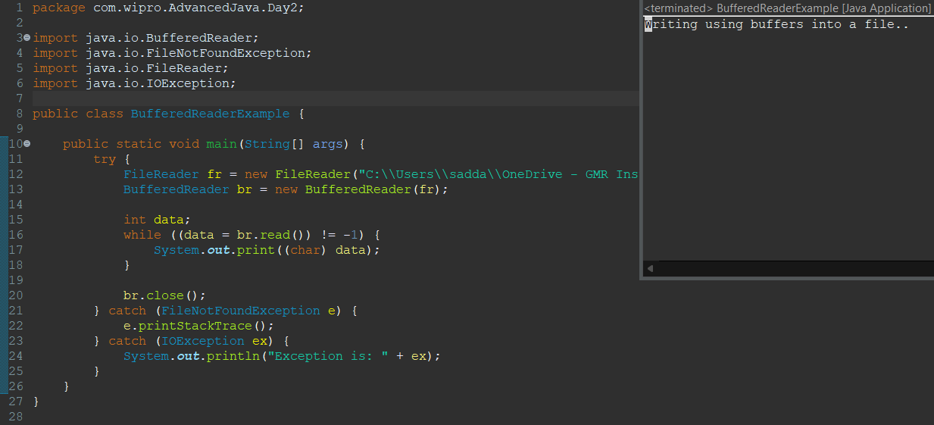



**Serialization**

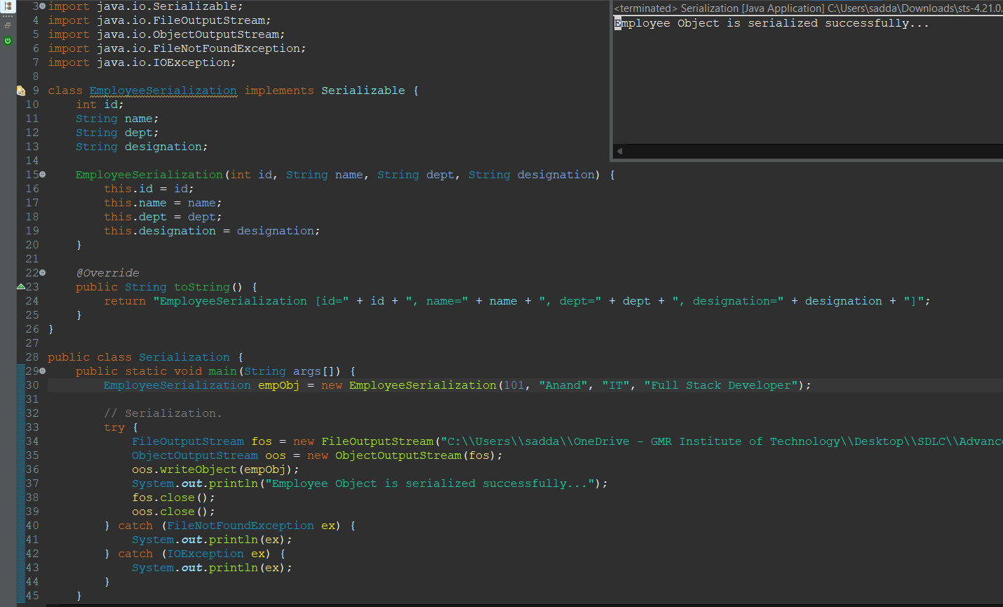

**Deserialization**

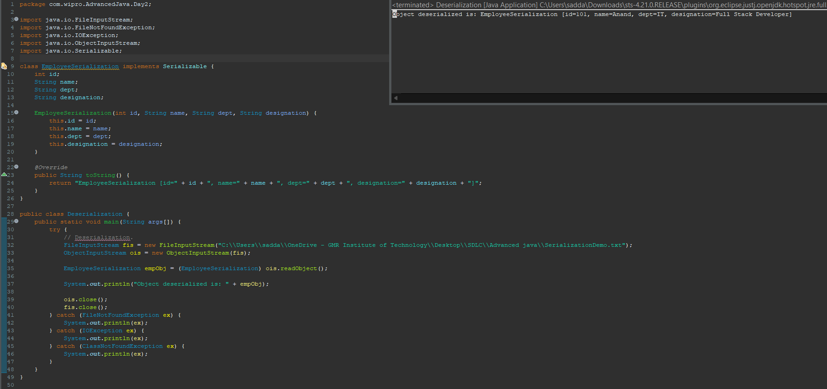

**Directory Operations**

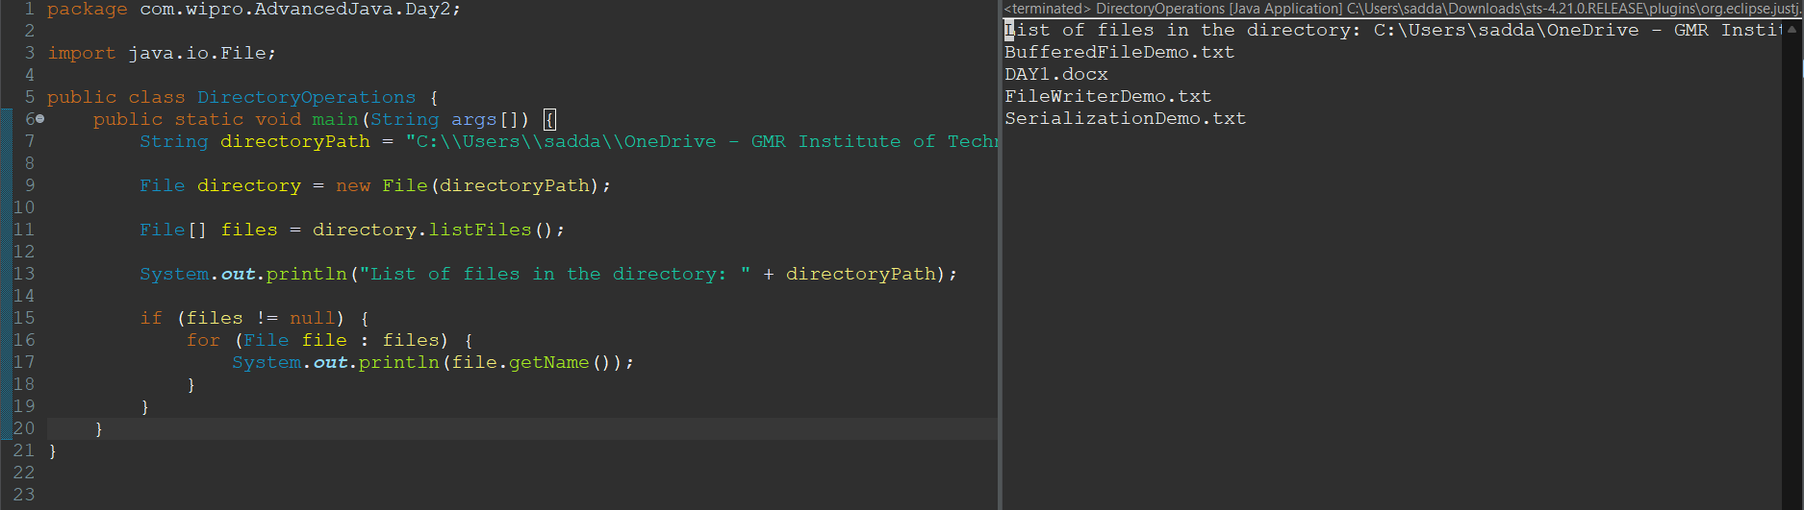

**Server Socket**

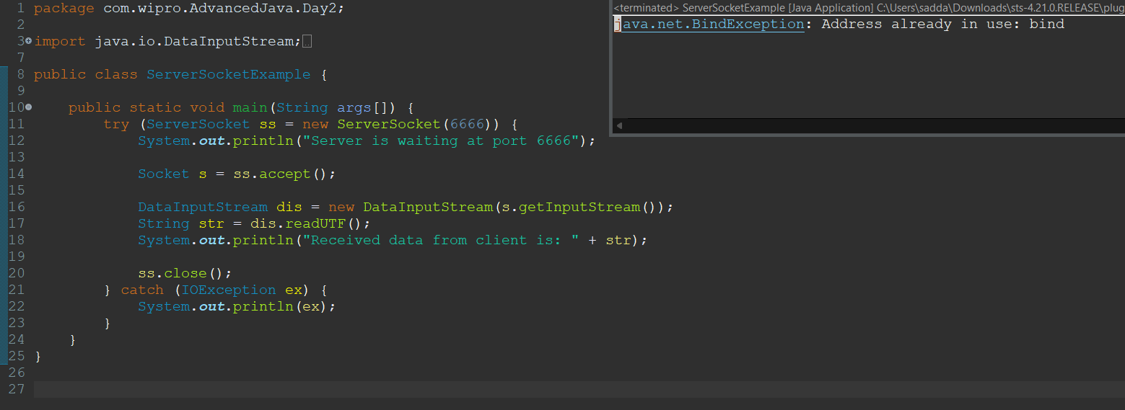

**Client Socket**

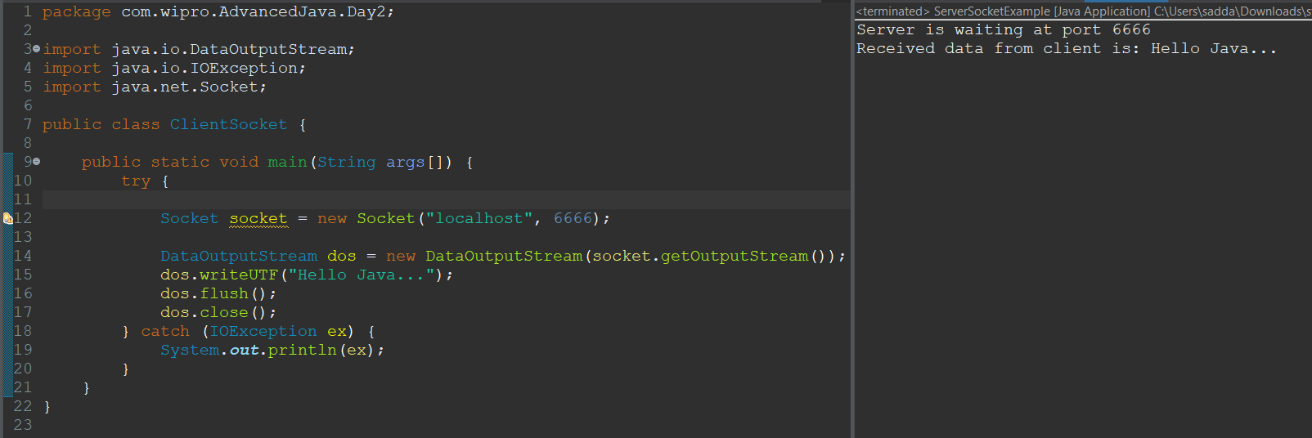

**URL**

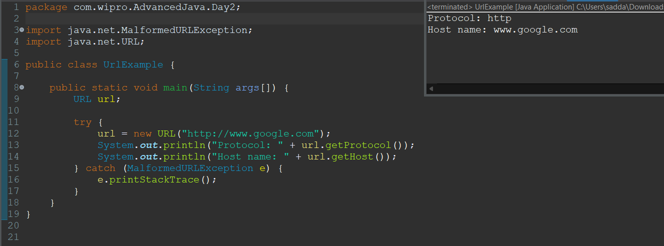

**InetAddress**

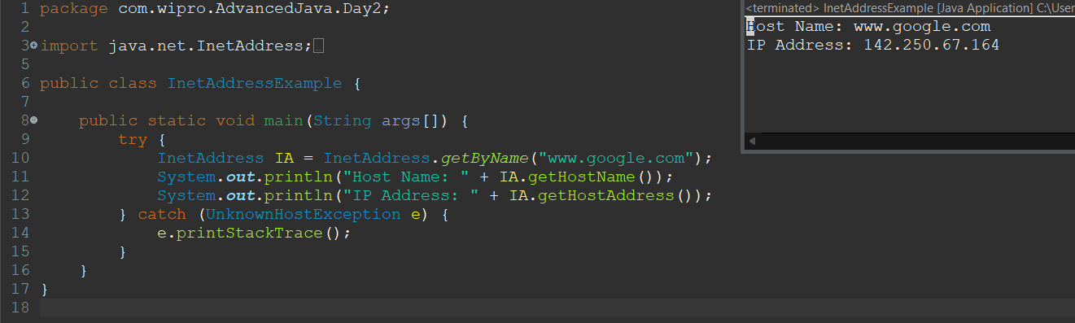

**LocalDate, LocalTime and LocalDateTime**

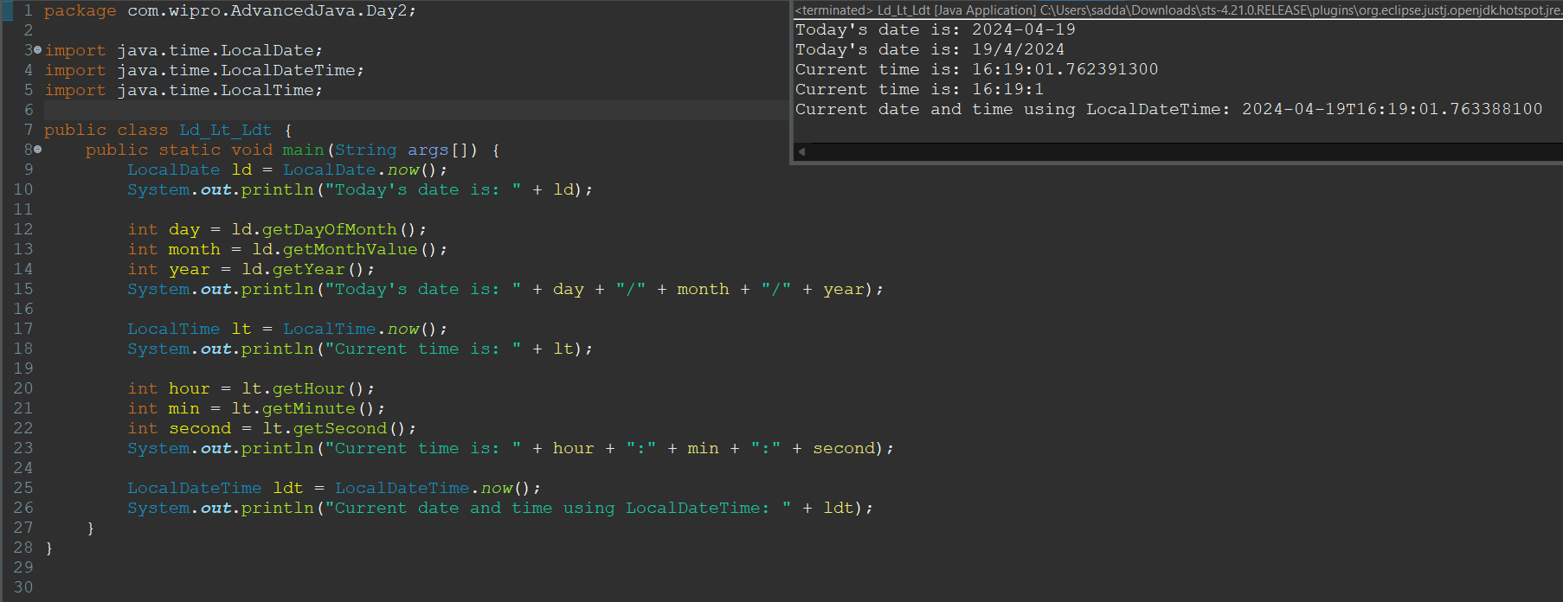

**Time Zones with ZoneIds**

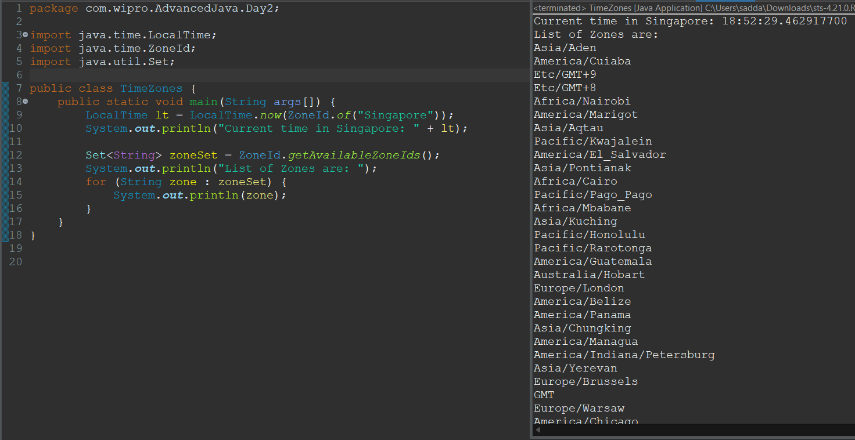

**Temporal Adjusters**

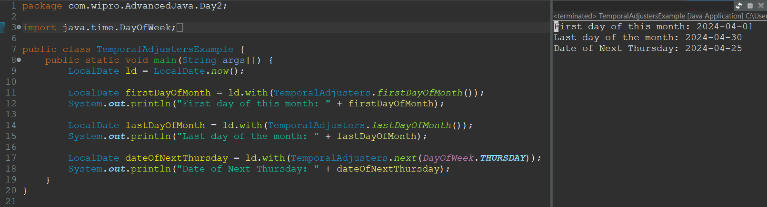

**Temporal Adjusters**

